  - Behavioral Modification and Submissive Training

An Academic Treatise 2015,
Aramock Nanuck, Ph.D.
Fetish University, Dark Castle Sin
Singapore
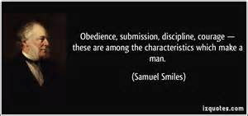
  - How the Workshop Happened
A local university as a part of it’s a sociology experiment and psychology assignment had embedded graduate students as analysts as a part of a fetish workshop last fall. The leader of the workshop (hereafter referred to as the “Dominar”) also holding a Ph.D. worked with the academic advisors and professors to make the experience as clinical as possible for the observers; while as real as possible for the participants. This paper is the result of these efforts. We held an 11-day workshop and practical programme on the “Art of Dominating”, where submissive and dominants working together learned in real terms how to live the lifestyle in a 24x7 situation. This was followed by a 2-dat debrief period. During the first week, none of the participants left the training facility. On the 8th day as a supposed social break, all members were taken to a local mall. The Observers accompanied, and watched discretely as the training continued and specific experiments were conducted in a public setting.

Implementing the Training Program
Clearly this workshop was a complex and high interactive event spread over many days. The preparation for it was a massive undertaking.

Selection
The dominants were selected for their skills in various areas but also based on the clinical assessment of their ability to control themselves and their ability to manage anger. They also were evaluated on their communications skills and the presence which they projected; in other words how commanding they were. The recent Forbes Magazine article on 8 Ways to assess leadership, coupled with some test run by the university clearly identified individuals with the capability to control, motivate and manage diverse personalities.

The submissive’s were each assessed by personality, skills, and flaws. This was done for an NON-lifestyle setting; then the data was compared to their self-described fetish profiles. These were screened and subjects were selected who would fit the spectrum of “strong to weak” personality, and socially acceptable factors.

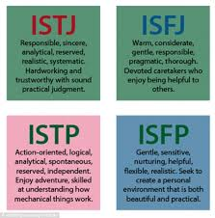
Matching
The submissive’s were then matched by the Dominar and Academic Advisors to give the broadest range of results and interpretations. The students observing, the dominants nor the submissives were aware of the selection and matching process. From a fetish perspective, the single point made was that the individuals would commit for the term of the workshop.

Trust
Prior to commencement of the workshop, the individuals were invited to 4 separate “munches” where they could mingle and exchange ideas and discuss their interests. This was essential to establish the trust dynamic between the dominants and the submissives and also with the Dominar. The second last of these sessions the observers were introduced and their roles were discussed. On the last session, an evening fetish event was held where some of the kinks were acted out. This allowed all parties to become comfortable with the 2-week session to follow. The trust quotient was assessed prior to starting the workshop via a series of questionnaires and confidence was high entering into the workshop that the matching was appropriate.

Organization
The planning was essential therefore trusting anyone’s memory or focus drove the risk of failure to unacceptable levels. All of the behaviour changes were mapped to individuals as was the specific goals, reasoning and approaches to be used initially. The frequency that situations would be triggered, the audience present even the props to enable it were all discussed, planned and recorded. The current status of each submissive and the behaviours exhibited prior to conditioning were listed. We also list the change expected, and how it would be measured; the time frame expected to realize noticeable changes were all listed. The student observers then applied their clinical tests and measures to what was defined and this became the “playbook” for the workshop.

Sharing the Plan
This was one of the most controversial items on the agenda; should the plans be shared or hidden from the submissives. It was clear if they knew the situations to be triggered, or what to expect then they could manipulate the results. However, some of the high-level expectations, goals and even changes in routine would have to be discussed so as to allow them to make informed decisions about their submission. Each of them was told the behaviours which were being targeted and in what to expect as punishment or reward. This was needed to get their agreement to the terms of the “Contract” for the session and reduced confusion, anger, and resentment. It also ensured that the academics had the tacit agreement of what could or could not be done or observed. Finally, and sexual acts were clearly listed as being either in or out of scope and under which conditions, and in all cases “safe-sex” (condoms, etc.) was mandatory. This made all of the training be more effective and less time was involved throughout the process going over the basics One cardinal rule was that at no point would a submissive be punished or rewarded without knowing why.

Implement Consistently and Objectively
It became clear from the start that individuals may freeze up with the non-fetish audience about. Just because individuals were being observed, punishments and rewards were not altered or disregarded. Also, simply because some was trying to manipulate a situation did alter the results. Diverting from the plan produces inconsistent results and the submissive will draw conclusions and alter behaviour accordingly. The goal was to avoid inadvertently reinforcing behaviours other than those desired. So some simple approach rules were:
- Don’t skip a punishment because a submissive did something cute.
- Don’t reward extra because you are in a good mood.
- Don’t play to the fetish needs when correcting behaviour.
  - Human Psychology Drivers Behavior Change
Many dominant consciously send vast amounts of time trying to understand how individual mental process work, and patterns which many people exhibit. Domination is not a matter just of lifestyle but of work, military, social and government; effectively it is an extension of “Organizational Behaviour” in a Social setting. Dominants learn tricks, skills and the tools to use as psychological levers to manipulate and control others in a series of complex social engagements. This part human psychology and personal study aids in understanding those forces at play daily in human interactions. Training individuals differ only with the intensity and duration spent on a single focused subject area.

From Thought to Instinct
This focus alters in an academic versus a lifestyle setting, by virtue that in a classroom it switches on and off. A workshop which emulates the lifestyle has NO off periods and hence ramps up the intensity and depth of the experience; constantly reinforcing and working at a more visceral level. The result is that decisions normally made at a conscious level become ingrained and start to adopt an autonomic or sub-conscious level on a broader and broader set of circumstances. Actions become instinctual rather than planned and thoughtful in the end.

The Goal
The whole process is about shaping behavior and having the actual match the anticipated actions. This Effectively occurs when dominants encourage rather than dictate the behaviours desire, and discourage those the ones not valued. Overtime; it is the intent to have these actions themselves become automatic responses in the submissive without the necessity of instructing or dictating. This is where substitution of wills occurs.

Dissent and Opinion
Concepts are like powerful fulcrums in the human psyche. The first time one comes across to an individual it etches a specific pattern in the mind of the individual. If other concepts do not come along quickly to challenge or come to reinforce the original concept; then govern the beliefs formed within the reality a person lives. Where ever just one version of reality exists is the fertile ground upon which fanaticism is born. Messianic religious and political leader use this approach with followers to solidify their power, control, and positions. Many learned people continue teaching for decades while still attending classes, forums and seminars regularly. Learning becomes a lifetime endeavor with new ideas or perspective to consider. There were members of the graduate programme and no doubt many others in the world at large who will disagree with the assessment or even if “proper” to use these skills. Many times these will be others who wish to inflict their own control on a large audience, or simply cannot accept that individuals can and are programmed every day to respond to the mental and social stimuli of those directing society, work, or the social morals of a community.

Boundaries and Agreements
The difference in a lifestyle framework is that in order to begin the Dominant must negotiate and have explicit consent from the submissive. Equally, submissives must set any limits or restrictions as a frame of reference with the Dominants in advance so as to ensure covenants are observed. This essentially becomes the CONTRACT (short or long term) for the engagement to occur. Total power exchange will take a larger toll as it meddles more permanently with a person’s personality deriding the precedence within BDSM of always getting consent first.

Kink as Therapy
Human sexuality until recently in most “polite” society has been something to keep hidden. Repression of the discussion of varied forms of fetish and alternative lifestyles continued to be held as inappropriate as late as the 1980’s in the west, and continues today in many of the most restrictive societies today. For many the discovery of their place in the world, their relationship with society and how to form the best relationships become a real benefit. The individual grows from the exploration of their persona and image associated in either a vanilla (non-kink) or fetish lifestyle. A catharsis occurs with delving into the variants of their sexuality has opened new vistas for them to explore. This quickly is followed by looking into the aspects of power exchange. Over the last 40 years, BDSM has emerged from the whispers about shadowy backrooms to a place where at least honest open discuss discussions take place.

Sociologists today have begun to even look at how this lifestyle can be applied in a therapeutic setting. It is important that dominants untrained in human psychology must resist the impulse to become a submissive’s therapist. Even if trained to offer that service there are good reasons that mental health professionals are strictly forbidden from treating family members or anyone else with whom they have a close relationship. If you partner has issues which rise to the level of being a mental disorder or which would generally require a professional, then that is who they should be seeing to deal with those things.

The National Coalition for Sexual Freedom in the United States maintains a list of “Kink Aware Professionals” who can help with counselling, medical, or other services; in other countries more effort needs to be taken to find this type of resource but most Mental Health Organizations can assist, and many maintain similar lists.

Informal Training
Daily everyone makes very pronounced and exact gestures, vocalizations or movements which communicate to those around them their emotions, and satisfaction level. The observant people in our sphere of influence pick up on things like a sigh, frown, smile, smirk or any other facial expression. Depending on the setting, situation, and personal perception these can alter another’s behavior. This will happen regardless of the nature of the relationship if there is an intimate or power difference aspect to the relationships. Frequently the response is subconscious. The intent of the dominant becomes to use this and deliberately use the automated response purposefully.

A Dominant’s Tool Box
Fully changing the way people act, not only in a dominant’s presence but 24 hours a day requires using tools effectively that have a more a perpetuating effect. There are numerous tools that can effectively underpin and force the sought after reactions of others. Taking the practices of business or military leadership and applying the psychology and learning theories in a fetish/kink or lifestyle setting is not as difficult as may seem. Control effectively is control regardless of where or how it used.

SECRET TOOL: Honest with oneself always a first step.

A Dominant’s Motivation
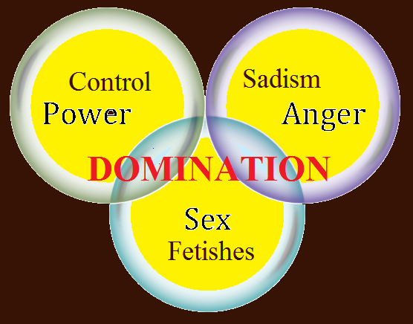
Many dominants ignore understanding themselves first. The needs and motivation for a Dominant engaging in the lifestyle are as varied as those of a submissive. Understanding one’s motivation requires assessing oneself in an honest perspective relative. The motivations have to extend to the reasons for entering into any relationship. It is only after the Dominant understands the aspects of self-interest can they then communicate these motivations to others. Submissives need to know a number of critical items before being able to commit and, therefore, should ask the Dominant:
- Why does the dominant want to train a submissive (and, in particular, the one asking)?
- What is the dominant’s goal(s) in providing or facilitating the training?
- What does the dominant want to get out of it the resulting relationship?
Until a Dominant can answer these questions in a very clear and thorough manner the submissive engage further. You need to stop and spend time on this.
SECRET TOOL: Add value in a real sense to the individual submitting.

Personal Goals
The things that stimulate and fulfill the desires of a submissive are essential in making a relationship valuable. If the submissive cannot articulate these clearly for themselves this is, even more, difficult at times. The dominant may have to be derived because the submissive covers the clues to the foundational goal with other more confusing elements. Many times this manifests itself in a destructive behavior but represents itself in other manners. A simple example of this is when a person ahs a poor self-body image, and has a number of affectations to harm or belittle themselves because of size or shape. What is truly wanted by the submissive is the strict enforcement of diet and exercise. The individual seeks a dominant to provide this as they lack the will power themselves to remain committed to a programme of self-improvement. Over time, the submissive loses the weight and in the process feel more comfortable with their own appearance These things are often neglected but are quite possibly more important than subsequent items because they make dynamic valuable like the submissive is getting something out of the relationship. Do not let the following items be overlooked:
• The items which embarrass the submissive
• The bad habits a submissive wished to eliminate
• The skills/activities that the submissive can’t do well
• The skills a submissive always wanted to learn
• The skills a submissive is proud in demonstrating
• The activities a submissive always wanted to do
• The activities that a submissive does to keep focused

Dominant’s Preference
The selfish desire to have a submissive fit a dominant's personal preference may not seem noble but is completely reasonable. Fulfilling one’s desires or fantasies NOT altruism is the main reason that people try to exert their will over another individual. The desires can be categorized, structured and planned and are frequently include in the agreement or contracts offered. The multi-tiered D/s dynamic (i.e.: Ones with alpha slaves) will distribute the workload through the structure however in any flat structure or one-to-one relationship the bulk of the fulfillment activities (heavy lifting) is usually the exclusive responsibility of the slave. Dominants requiring special skills, however, will have to adopt aspects of the second reason. For example, if a requirement for flexibility, stamina and endurance are required in some of the fetish activities the dominant may need to send a submissive to yoga class. Other examples are:
• Routine and scheduled activities
• Selecting favourite food, drinks, music, etc.
• Preparation and presentation of food
• Protocols, rules, and consequences

Skill or Behaviour Development
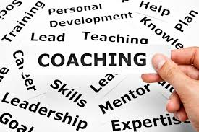
General skill development is the training of a submissive to do that which is valuable outside the relationship with the dominant. This type of development provides an added incentive for the subject to submit. While it is unnecessary for the dominant to actually provide or facilitate such training it is invariably appreciated. It is not necessarily for the dominant to actually conduct the training especially if they are not qualified to do so. Therefore, If a particular skill is required of a submissive, like cooking or cleaning or massage or manicure, there are places where someone else will do the. A good example is learning advanced techniques in giving Thai, or Therapeutic massages are useful regardless who someone is with. Other general skills of value are:
• Business Communication and Secretarial
• Event Coordination
• Facilities Management
• Personal Grooming and Presentation

Conversely, if there are particular stances, poses or adornments which a dominant requires; these are all a matter of personal taste. These skills may be valuable inside a fetish relationship and even be transferable between dominants, (I.E.: knowing exactly how far apart a submissive must place their knees to be when kneeling). Clearly understanding the difference between private, fetish and generally “marketable” skill is essential. The more altruistic will provide marketable skills to academically deprived individuals.
  - Cravings determine the Role as a Submissive
The assuming the mantle of a slave is very much an extension of being submissive. Individuals become submissive for reasons as numerous as the people choosing to submit. This was discussed in the article “Being Submissive”. However, a lot of the reasons is to realize a deep-seated need reflected in service. Driving this is a desire for:
- Active Service – where fulfillment by completing activities for others, such as cooking, performing, managing the dominant’s schedule or oral sex.
- Passive Service – the things that the submissive allows being done for the pleasure such as body painting, flogging, or sexual use.

The emotional release comes from:
- Independence – the desire to act without the direct instruction of the dominant
- Selflessness – the motivation from pleasing others

These factors are used to determine:
- The compatibility a person has for being submissive.
- The training approach that is most likely to yield success.
- The intensity of training required supporting the transition.
- The positive result of interactions in developing a strong relationship.

Matching Motivation
Starting a new relationship requires taking seriously the above factors into account. These factors need to be reviewed regularly if the intent is to maintain a strong D/s relationship on an ongoing. Casual activities, training, and more intense sessions need to be viewed in the context of the above factors as well.

Giving the proper attention to matching motivation is essential when a Dominant thinks about beginning any kind of training. Giving importance to the role and person of the submissive require the Dominant to understand the motivation which drives the submissive.

- A service based submissive will respond less positively from punishment or humiliation as they view this outside their core needs. They also are less likely to act in a way to require discipline as their motivation is tied to service fulfillment.
- Likewise, the masochist will respond weakly to demands of service. The pain-slut will misbehave with the intention of being punished and feel rejected if they do not get the crack of the whip.
- The sexually motivated submissive will rebel is the intimation of sexual congress is not a part of the activities conducted.
- A captivity slave needs to feel the control in everything and even making the smallest of decisions need to be removed from them. They thrive in environments where there is a total suppression of freedom.
Care must be taken to apply the reinforcements that continue to feed the needs of the submissive in particular. The facial expression can convey displeasure and the subject will notice it and will change their behavior. It is critical that the verbal matches the visual clues the dominant is sending; this level of attention to detail is essential in all active sessions to ensure that the feedback is appropriate to the situation. Regardless all submissives reminders of the power exchange as a part of the bolstering of their function. Failing to give the needed energy to revitalize the submissive’s reality will leave them either trying to top-from-the-bottom or could ultimately have them looking for a new dominant. Thus, it is less a choice and more an imperative for the dominant to take a pro-active and practical approach to conditioning.

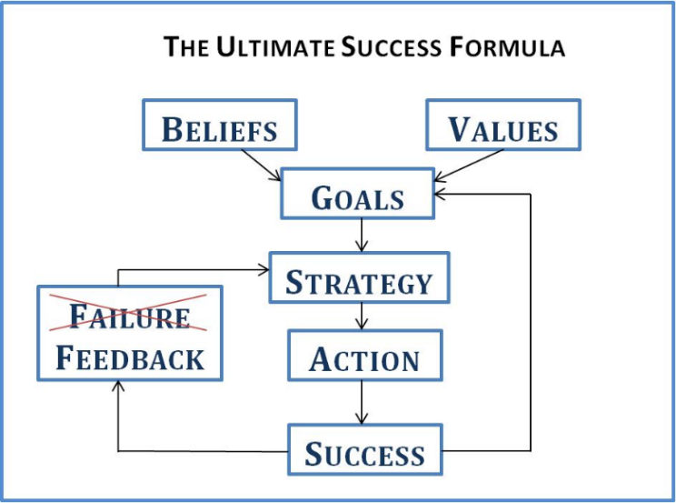
Pro-active is Being-Prepared
Every good Boy Scout knows the need to “Be Prepared”. Dominants are aware that behavioural modification is a learned skill. They also know that learning is built upon both the carrot and the stick approach to training. Knowing the types of conditioning work in which cases is where being prepared comes into play. This means that the “thinking” Dominant must apply an intellectual understanding of the expectations of both parties.
  - Making the Change
The collective work by Ivan Pavlov, BF Skinner and Edward Thorndike all contribute to the fundamentals of these approaches. Effective behavior modification is drawn from their analysis in the past. What is different is the application to BDSM and willing submissives rather than uninformed or low-intelligence or even unwilling subjects. Behavioural conditioning cannot truly occur without both making some adjustments. It is though a matter of degree in which is used in how much of the effect is attained. This is probably the most difficult to map because over time each of the recipients changes their needs and the effect that both the reward and punishment have as motivations.
SECRET TOOL: Conditioning a submissive is like working leather to be functional, slow, precise, repetitive and patience is required.

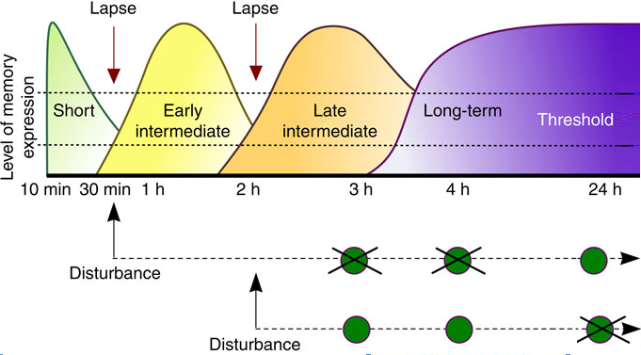
The concepts of conditioning (Manchurian Candidate) are ideal for the fetish lifestyle of D/s. Any behavioural modification process to be effective needs to ensure that the response is predictable, repeatable and within the tolerance expected given a common situation. The environment can alter the expectation but with reinforcement, location, public or private should have limited effect on the results if sufficient reinforcement has been applied. If responses have been trained into (or conditioned) the any given stimulus or instruction becomes increasingly effective in evoking a response. The more the regular the instructions are issues in a stable environment the more likely it is that the response will reoccur when in unfamiliar situations. The subject will then fall back on a pattern response independent of the environment of context.
The submissive is made plyable against other influences or an athlete receiving rigorous physical training become fit for competition. The submissive requires a high degree of psychological conditioning to take place, re-shaping their mind to accept the risks and follow instructions while disregarding the effect; trusting the dominant to make the choices which are correct and necessary for them.

Associative Conditioning
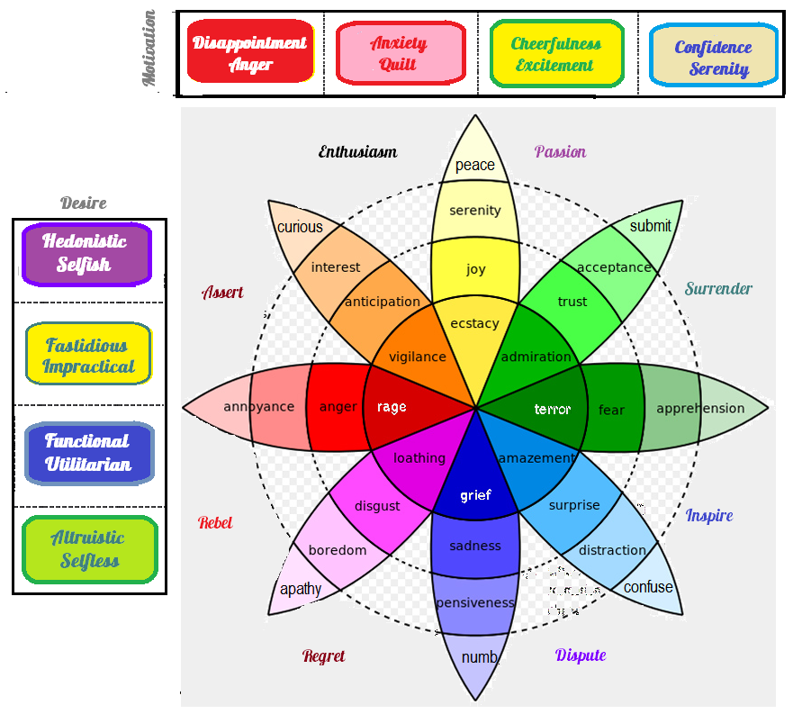
The Pavlovian response is the most recognized in this form of conditioning. Pavlov (a Russian scientist) rang a bell each time he fed the dog. Over the progress of time whenever the dog heard the bell, it would begin to salivate. This was simply a result of the dog associating the sound of the bell with food in the dog’s brain. Applying association in the context of a slave is the use of a particular toy is regularly used in conjunction with sexual pleasure, then the sight or feel of that toy will eventually start to elicit a sexual arousal response, even if it is not a sexual toy. The effectiveness of this was proven during the workshop; a new slave was given orgasms 8 – 12 times a day with specifically colored and shaped “Zini” vibrator. After the 5th day merely seeing the vibrator caused obvious sexual arousal in the subject. It was noted by the graduate students deemed this as a “reward” based associative conditioned reflex. They further asserted that individual in question was seriously sexually motivated to begin with and at the low norm of the IQ (104) spectrum. Regardless of the interpretation, it is not disputed that the conditioned response could simply speeding things up or used to tease and torment the subject in public.

Negative Associations
The application of a negative association is a very powerful deterrent in place of punishment in public places. The dominant slapping the side of their thigh can be associated with impending punishment. This quickly and effectively and let the submissive know they are in trouble. Again this was tested during the workshop, each time a dominant was about to punish any submissive (and he was training 3 during the event) he would first loudly smack his thigh. Typically the Dominant was provided cause to punish the submissives to varying degree at a minimum of 4 times a day. There were 2 days where one submissive was punished 11 times. All of the submissives were present for all of the lead ups to punishing and most cases were present to observe the punishment taking place. On a number of occasions other dominant or submissive individuals also observed the lead-up or delivery of punishment. On day 8 in the mall, a small situation was staged by students who the participants were unaware of but part of the academic assessment. The goal was to force a disciplinary situation and determine if the dominant used the soft negative associative techniques or opted for actually punishing the offending submissive. The effect was absolutely immediate. The dominant slapped his thigh and approached the submissive. The submissive immediately took a docile stance with eyes facing the floor and hands clasped behind the small of its back. The dominant then spoke to the submissive, which immediate apologized to everyone present, and turned leaving the group. Later it was discovered they went to wait by the vehicle in the car park. Upon interviews conducted it was shown that not only the offending party reacted but so did all of the other submissives thus trained. Other observers saw each of them take the same stance and await the action of the dominant. It was only after the dominant approached one spoke and the other left and the dominant did not approach any others… that they resumed their halted activities. This clearly showed how quickly a negative associative training could be made effective.

Avoiding Confusing Signals
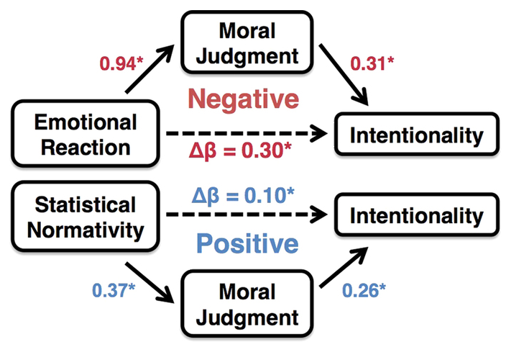
It is important to make all of these associative conditioning tied to stimuli that are rarely encounter in day to day life. Intelligent use of all of the senses (smell, touch, taste, sight, and sound) can be used and as a few are combined and becomes deeper and more impactful (like the slap of one’s thigh… sight, sound, and action). This eliminates the confusion and “watering down” of the effect of the stimulus and far less likely to occur in an unrelated situation. Therefore, any stimulus likely to occur in a workplace or traditional setting would be ineffectual. It is essential that the stimulus is very hard to occur accidentally the override the association. Effective stimulus needs to be provided and associated only with the dominant ensuring as much control over the stimulus as is possible.

Operant Conditioning
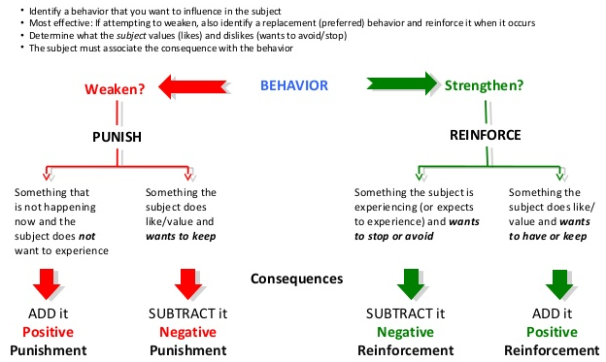
Most people picture conditioning like training pets (in particular dogs or horses) with a series of rewards and punishments. The lifestyle uses rewards as a part of wish fulfillment and less so as a conditioning tool. The intent, however, is for the dominant to provide intentional inputs which either encourages or discourages whether the submissive deliberately or not exhibits certain behaviours.
Simply differences in style should amplify the message such as:
  - Using their real or pet (lifestyle) name for them,
  - Looking at them in the face, or past them, or even not focusing at all,
  - The use of lack of use of adjectives and or profanity
  - Finally, if you ignore their responses and actions entirely.
Clearly the use of body language, facial expressions, and the words or intonation used should always convey a message. Applying these factors acts as conditioning that are consequences aimed at modifying the voluntary behaviour of the submissive. The operational part is from associating certain behaviour consistently to a very specific set of consequences.

Reinforcing Change

Constant Reinforcement
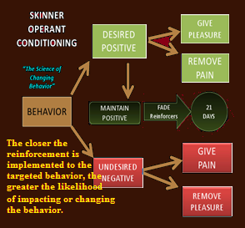
Everyone gives out signals which can be interpreted by others and in doing so apply pre-set responses. This is effectively the most subtle form of conditioning that exists. The major difference is that these types of signals are very specific and generally not managed in a thoughtful of the predefined situation. Their effectiveness ranges from mild to non-existent depend on a myriad of conditions; and as such make poor mechanisms establish control. Frequently the patterns adopted are those to suit others not one’s self. The actions then carried out are the most subtle communications forms we have. There is little incentive of structure around which the people interpreting them can establish future actions therefore ultimately become dissatisfying.

Effectiveness for Positive and Negative Reinforcements
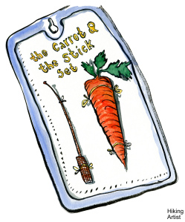
The efficacy of giving a positive reinforcement compared to negative reinforcements was measured. Patterns showed that depending on whether we were correcting a bad habit or instilling a positive response the effectiveness of positive to negative reinforcements differed. So allowing a submissive to have an orgasm was more effective as a positive reinforcement than denying orgasms as a negative one. Part of this was there were opportunities where a submissive could provide their own orgasms at a different time when they believed they were NOT being observed which undermined it as a denial deterrent.

Positive Reinforcements
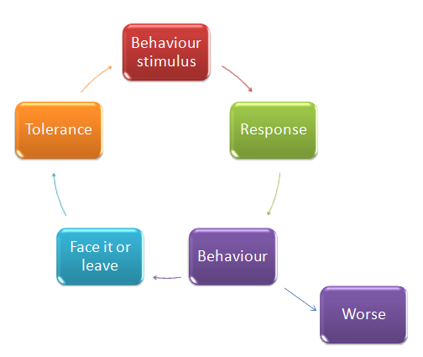
This reinforcement is commonly believed understood and applied by most people. The term “bribe” however comes to mind, and can have a counter-intuitive effect if overly used. If the reinforcement becomes a bribe, over time the subject receiving the bribe begins to expect it and believes it is their right to have the bribe. This is why corruption in some places (like the Philippines) is impossible to eradicate. The difference between a bribe and a reward is that the reward is for an exceptional act, whereas the bribe is for doing a mundane activity which should be completed regardless if extraordinary compensation is provided. Classically the person who responds correctly is given a little special attention. This attention equates to a “treat” when dealing with pets. It does not does not have to be a real treat but a pat on the head suffices in many situations. The verbal affirmations that accompany a pat on the head “good boy, good girl” reinforces the positive nature of the reinforcement. As with the Pavlovian response now the words “good boy” equate the treat and affirm the reinforced the behaviour. Over time the more consistently applied, the more effective the positive reinforcement becomes. Also by not making it material, it never becomes a material benefit or confused with a bribe.

Negative Reinforcement
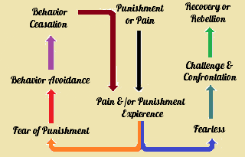
This takes to a level of discrete “Escape, Relief or Avoidance” in place of the flight aspects of the fight or flight syndrome. Caution always has to be taken to not make the overt and repressive nature of the negative reinforcement such that the “fight” effect is triggered. N the BDSM lifestyle fight usually means an emotional and or physical lashing out by the submissive; where they leave the dominant with the sole intent of exacting revenge for the imagined damage done. This has negative effects not only on the relationship and all people associate with either side of the relationship but also on the fetish community as a whole.
The best way to invoke the negative reinforcement is to actually remove an adverse stimulus in response to an undesired behaviour being avoided or corrected by the submissive. This usually is enacted by direct response training, for example a submissive is playing music loudly; the dominant takes the source of the music from the submissive and locks it in a cabinet. The dominant then explains that music can be played at times when appropriate but never loud enough to disturb the dominant, or others in the household. If the situation repeats, the submissive will lose the privilege to listen to their music for 2 weeks. Guaranteed the submissive will not risk losing the privilege again and avoid playing music loudly again.

Avoidance Training
It must be made clear that negative reinforcement is NOT to be confused with punishing a bad behaviour. Negative reinforcement is a mechanism to avoid negative consequences. It is usually coupled with or immediate following a punishment. It defines the actions which are NOT desirable and the impending effect if those activities continue. Submissive will learn to avoid the repercussions if made clear and precise as to what is viewed as undesirable action.
This then leads to the process of active avoidance; effectively a submissive learns the things which are viewed as being NOT desirable and the impact of breaching these standards. They begin to activity act in such a way as to avoid the negative reinforcements altogether. If we take a nominal practice in a relationship within BDSM we observe parallels.

How to use negative reinforcement for training
Assume that every Friday is a particularly annoying nipple clamp day. When the dominant gets home from work automatically he applies the nipple clamps to the submissive for up to 2 hours. The submissive learns that over time that if the submissive is particularly attentive and “good” the nipple clamps are removed early. The dominant never has to say anything out loud, but simply removes the clamps for good behaviour ahead of scheduled. The dominant changes the dynamic by announcing that the performance all week by the submissive was so exemplary that he is not going to put the clamps on at all. This new information acts as an extension of the active avoidance; where the submissive realizes that continued exemplary behaviour avoids the nipple clamps ever being applied.

Conditioning Begins with Politeness and Etiquette
Many of these patterns are challenge and response actions that have been trained into individuals on a social level. “The holding of a door for another” is a subtle sign of respect; more importantly, it is noticed not only by the people involved but also any observers. One’s “Ps & Qs” is one of the most important communications skills we learn; “please and thank-you” engenders a “polite” social interaction. Etiquette is an extension of these making broader impacts. The fetish lifestyle and, in particular, D/s assume politeness as a necessary cornerstone in its protocols and rituals. During the workshop, one of the constants was the training in protocol and civility to a level that in todays rushed environment (particularly in Singapore) seems quite anachronistic. Yet the attendees took to high protocol with relish, and the sense of formality and respect it gave in both directions was one of the most remarkable aspects of the training that the observers recorded. They saw that in fact a failure in protocol usually results in the punishment of shaming the individuals involved. One dominant would correct another dominant, and the dominants would be harshly critical and humiliate any submissive who did not exercise precise respectful forms of communications, both verbally and with body language. One observer remarked the stance the Dominar took when correcting others, which provided a model for others. Never did he use profanity or shout, but in fact when truly upset he became very still, his voice became deeper than normal, and his tone was measured almost quieting, while his words became very precise and pointed. This pattern showed such control and discipline, that his anger was far more tenable than going the other way. “Its effect was remarkable and unforgettable as opposed to raging like a bull,“ noted the observer.
SECRET TOOL: Effectiveness is a matter of Control, which in turn is a matter of Presence

Impact and Commitment
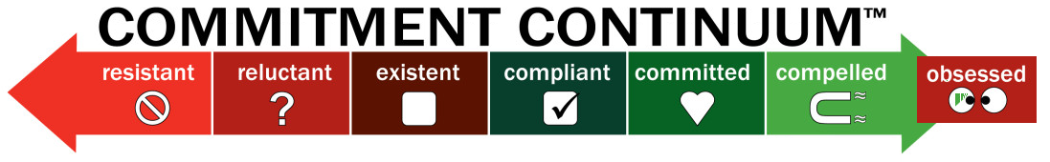The observers began the workshop with the presumption that little effect would be measured, and while interesting not much would be learned in a few weeks. Most texts and discussion by other academics asserted it takes months if not years to effectively create these patterns. The observers, however, found this NOT to be the case, and in ALL situations, it did not take more than a few days for the conditioning to take hold. The observers then counter that the people involved were predisposed to conditioning but no empirical evidence was presented to support this collateral assumption. The academic advisors also were unbelieving of the rapid effects and asked to do follow-up investigations months later. The academics discoveries were that in all cases where a bond had been formed and the conditioning continued it not only was reinforced but extended to a broader community.

Demonstrable and Repeatable
One of the observers with a lecturer repeated the thigh slap with the dominant and a submissive thus trained. The difference was that the student set up the situation to cause a failure, but it was the academic advisor who was the recipient of the offense by the submissive. When the academic advisor slapped his thigh the submissive immediately repeated the process and forms she had with her own dominant months before. This not only showed the power of the conditioning but that it was a transferable pattern.

A seed changes in Reasoning
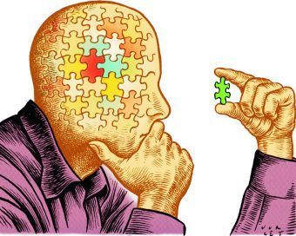
The discussions in class following the demonstration became heated. The Dominant and submissive were invited to join about half way through, and a videotape was shown of the incident taken from across the mall by a student using a video phone. While the dialog was not audible the visual effects were clear. The students questioned at length the scenario and the responses from the dominant and submissive. In the end, the best answer that was given by the submissive when asked “Why did you no ignore the thigh slap?” was a very quizzical look and then “Why would I?” The concept of disregarding the stimuli had been totally eradicated from the submissive’s mind. It was clear that the conditioning never to be a single thing said out loud and effective training can be done without the need of giving explicit instructions.

Punishment is a Consequence NOT Conditioning
If you wish to discourage a specific behaviour or force atonement for some infraction the discipline becomes that consequence. It must be clear that consequences differ from conditioning in one significant fashion. Consequences only occur as a result of something occurring, whereas conditioning is applied to promote or prevent the occurrence. Hence, think of punishment as a form of conditioning is misleading, it is a consequence. Broad spectrum punishments will never have an associative factor to them; hence, the subject does not know for certain the action will result in the consequence. This KNOWING is where the application of consequence becomes conditioning. The conditioning is to have the subject to desire to avoid the consequence or receive the reward. There are different forms of discipline and the effect adjusts accordingly. The terminology sometimes used in connection to punishment is “Positive” versus “Negative”, however, while these do not mean good or bad they also are considered limiting in the scope of what is to be achieved. Positive is adding something and negative is taking something away. However, the effectiveness of discipline as a whole is in the nature of how it occurs not what it delivers. Hence the concepts of knowing what to expect, “predictive” and knowing what is the effect “denial” or “corporal” have far more power in building conditioning from the consequences realized. The functional part is however consistency, reinforcement and illustration. Individuals need to know why they are being punished, and have the punishments corresponded to the activity in order to build a conditioned effect. Regardless, if the disciplinarian is responding to an activity by definition this indicates it is an undesired activity or behaviour.

Predictive Discipline
Thus is the inflicting a specific punishment in response to an undesired behaviour. The punishment needs to be specific so it is associated with the event/activity/response which is not desired. This was clear in one type of punishment used during the workshop for all submissive’s when it occurred. Profane language (swearing, etc.) was never allowed. The submissive’s could express even sexual interest or excitement but had to do so intelligently with creative language. Failing to do so inevitably had a bar of lye soap wetted and placed in their mouths. This is a most uncomfortable act. The taste lingers for hours. Many subjects had quite foul mouths when arriving, within days the level of vulgarity reduced to a trickle and was virtually non-existent by day four. The consequence had become a deterrent and was only used for this specific issue. Clear, precise and repetitive without exception meant it became an extremely strong deterrent and thus conditioned the subjects to avoid it.

The collar forms a basis of another form of discipline which can be tied to specific situations or conditions. Most people are familiar with electronic collars and fences used to prevent a dog from leaving a yard. These are easily adapted in larger facilities to specific areas of the house. The basic function is that the collar is passive, and reacts to an electronic field of a certain amperage and resonance. The wearer as approaching the emitters (usually a wire antenna) gets a mild shock which increases in intensity as they approach. Typical the range is set for 90, 60 and 30 cm (3,2, and 1 feet) with the intensity doubling as proximity increases to the restricted area.

One dominant used this with a large woman, who was restricted from the kitchen or leaving the facilities for the duration of the workshop; except when escorted by the dominant. The amplitude of the shock was trebled during the periods of the workshop. An anti-tampering device was added which gave a maximum shock if interfered with. This was demonstrated, it also was sent so all metal parts of the collar would shock, so even if another submissive tried to free the subject they would receive the same shock. The first couple days on occasion the submissive would test the effectiveness of the restraint. Her distress was heard when this occurred. Only 3 other times did this occur as the workshop progressed. The first time was when curiosity and wanting to test if the demo was real or just set-up. The other two were as she inadvertently ventured too closely to restricted zones. The diet of the subject was sufficient to maintain her health but extremely restrictive, only 600 kcal/day.

The observers did not that on four occasions other submissives did sneak food for the subject of this experiment. These were not reported to the dominant in question by the observers, and clearly a guilty pleasure was had. There were two occasions, however, where this was discovered by the dominant. He punished the offenders, by denying them any special items or treats for the following two days. In all cases none of the offenders repeated the breach as the loss of their privileges was not worth the perceived kindness to the managed slave. The subject was given two minutes of shocks each time at medium intensity as well.

However, the observers noted that the subject’s motivation did NOT change, and still continued to accept food from others on each occasion after the punishment. This proved that the consequence, in this case, was a deterrent to the active breach of the rule, but did not condition the subject to avoid the actual intent of the discipline provided. The academic advisors postulate that either the desire was too high for the deterrent to be effective, or the lack of communications of the real intent and reinforcing this verbally as each incident was corrected show that without the intellectual association the consequence remained just that and failed to condition a response.

Clearly wilful individuals are less effectively controlled by consequences and fail to process these into conditioned responses. Further study on this is warranted and may occur in future workshops. It was obvious that the subtle administration of rewards and punishments without explicit intellectual support failed in intelligent individuals. The question raised is if less intellectually attributed individuals would find this more effective, or as a group we should acknowledgement that humans are less prone to conditioning through deterrent than pets.

Denial Discipline
The case above saw one example of denial discipline, when the submissive’s sharing food were denied treat for doing so. This demonstrates the removal of an implied advantage or benefit as a form or correcting undesired activity. Again it was proportional and fully linked to the activity which was not wanted. This denial of a privilege was used further throughout the workshop. Personal comfort is important to everyone, and any removal of something which provides such comfort is deemed repressive or a punishment. None of the subjects were permitted to sit on furniture except with specific and prior permission issued by their dominant or the workshop Dominar. All of the submissives had specific chores and duties to perform.

Sometimes more was expected than other times. Each morning specific task were assigned, and these were monitored. On one occasion a submissive assigned to clean the parlour (living room) did so while sitting on the furniture. The Dominar observed this and instruct all in the house that for 3 days, that individual was not allowed to use ANY furniture. On another occasion, a submissive was caught napping on a bed without permission during a time when they were to be doing chores. The submissive in questions was thereafter forced to sleep in a dog cage for the duration of the workshop.

The observers felt in both case the restrictions were harsh and question the Dominar in private. He told them if they interfered their right to observe would be cancelled, and their academic advisor informed that any further involvement would be curtailed.

In this case, it was NOT the submissives who were actually deterred but the observers. This workshop and the efforts with the university took months to arrange. Cancelling the university’s involvement would be a loss of face to the university and the academic advisors. The students themselves would have received an “Incomplete” for the assignment. This is a clear case of how the Denial Discipline of the submissive was converted into a consequence and conditioning of the academic observers. The denial for the submissives was NOT long term, however, the effect on the students was certainly for the duration of the workshop, and no other challenges to the Domino's approach or ruling ever came from forward. This was a lesson learned across all involved in the workshop.

Corporal Discipline
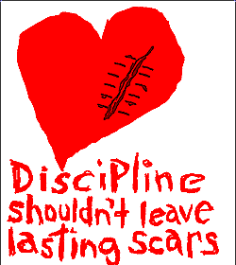
This was the hardest discipline for the observers to accept; which is quite astonishing as they all originated from Singapore with a strong social propensity to corporal punishment. One of the aspects which they found troublesome was that in Singaporean society punishment is always delivered behind closed doors and by an authority figure. Caning in prison by hooded guards, in a child’s bedroom by a parent… in each case it was something everyone was aware of, and in fact believed in culturally but the individuals themselves did not want to see or be a part of it. Corporal discipline during the workshop frequently included the slapping of cheek, back of the hands, bare bottom spanking, etc. It should be noted none of the harsher acts (whips, crops, etc. were ever considered “punishments” they were reserved for a part of the Sado-Maso activities that were non-discipline related. This distinction became apparent to the academic observers after about 3-days into the workshop.

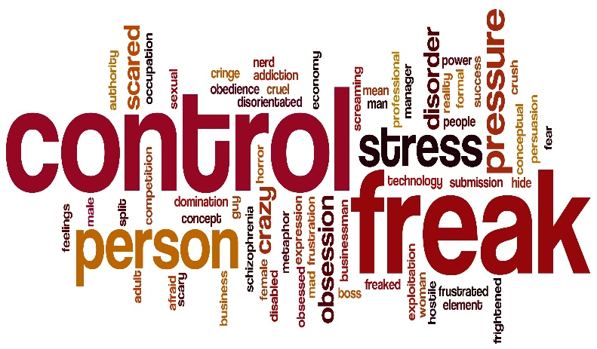
One incident, in particular, created some discussion after the fact with the academic observers. This was a particular case where on the fourth day a submissive was being bratty and was ignoring the basic instructions of her dominant. The dominant (also a female) had ordered the submissive to change for the third time in a row, the submissive felt it was unreasonable and challenged the instruction by throwing the clothes provided on the floor and stamping her feet. The dominant grabbed the thick hair at the back of the submissive’s head and forced her forward and onto her knees. The dominant then reached with the other hand and grabbed the back of the shirt and pulled it up. The submissive grabbed the front and pulled down. The dominant slapped the submissive’s cheek and hands and then pulled the shirt over the head of the submissive while still holding the hair. Releasing the hair with the other hand, she tears the top down the seam and it fell free to the floor. Pushing the submissive forward, she then grabbed the back of the skirt, on either side of the zipper and tore it apart. The submissive wiggled on the floor. The dominant placed her foot in the middle of the back between the shoulder blades and pressed her to the floor. Taking a nearby leather belt struck the buttocks twice and then announced, “When I say change, you will change… now do so! “, releasing the submissive she stood clear. This happened in mere second and in the full view of eight individuals attending the workshop, and three observers. The submissive realizing she had lost the contest of wills came up from a prone to kneeling position, head facing the ground and said “Apologies Mistress, may this worthless excuse for a servant please go and do as you bid?” The dominant nodded and the scene ended.

Events Happen
Many of the events for control were staged or circumstances were created to force the development of and test the effectiveness of conditioning and punishment. However, in the vast majority of cases, the dynamic of having such a large group in such a confined space focused on specific activities naturally gave rise to these occurring. Many like the item stated just previously could never have been contrived. The reactions showed in all cases a level of control on the parts of the dominants that was unexpected by the academic observers. The concept that people would react and manage such situations with the absences of malice was largely foreign to them. The discussions after the above incident were largely focused on why the severity of the reaction by the dominant and the emotions felt by the dominant. Out of the examinations, it was clear that this was solely an exercise in control on the part of the Dominant. Had she not forced the settlement her authority over the submissive would always be questioned, not only by the other around but more importantly by the submissive herself. The response, while not planned, was measured to exact the level of control through humiliation that would reinforce the position of authority she yields over the submissive.

Erosion
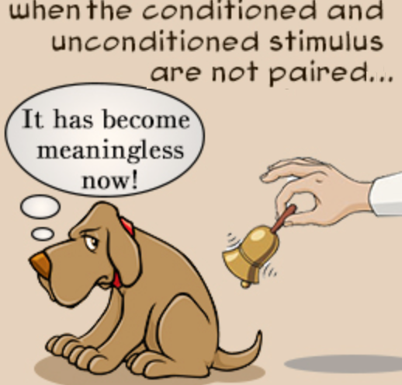
The problem with conditioning is that without constant reinforcement its foundations wear or erode” making them less effective. Many other researchers refer to “extinction” but most of the clinical studies showed some element of the conditioning remains. Hence extinction is an overly dramatic and final term to apply. Clearly erosion can be seen when the visual object which was the source of torment fails to bring forth the expression of fear. It is also the power lost as a phrase is overused and, more importantly, the corresponding repercussions are not forthcoming. Effective it becomes apparent when being told to “get the crop” no longer makes a submissive tremble. Once an instruction or simulation to trigger a response becomes meaningless… it ceases to have a value. Dominants must enforce the consequences and never allow delay enforcing the conditioning, otherwise the conditioning will stop working. The submissive’s behaviour will stop being influenced by the conditioning. Preventing erosion requires designing a plan that takes the minimal of effort to strengthen the conditioning and maintain its effectiveness.

Schedules
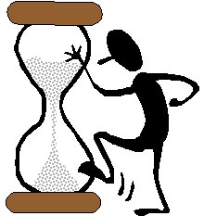
Outside of the workshop, most of the submissives and all of the dominants had jobs and other involvements which consumed significant portions of their time. Resulting from the workshop a number of relationships emerged and formed bonding sets which continued. A few of the individuals returned to a solitary life with casual involvement in the lifestyle. It became clear to those who remained in the lifestyle that the consistency/regularity of the punishment or reward would be a cornerstone of a continued D/s relationship. The other concerns and drains on their attentions meant there simply was a limited amount of free time. This coupled to the proximity issue; submissives being at different jobs, locations or homes from the dominant made constant control a practical impossibility. Therefore, it is simply was not possible to respond either to everything that a submissive did as they did it.

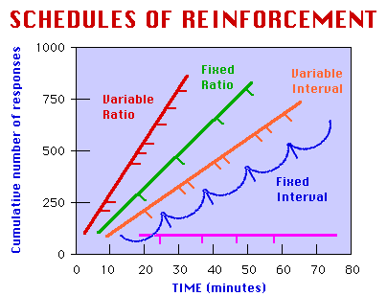
Researchers have found in studies of operant conditioning, that behaviours remain influenced by a punishment or reward, even if it doesn’t happen every time. Therefore continual reinforcement was not an absolute requirement but that it could be almost as effective to punish on a schedule. This has the advantage to increase the efficient use of both a Dominant’s and submissive’s availability. During the workshop, the dominants worked with the students to develop a simplified reinforcement schedule. They had to define the type of reinforcement (punishment or reward) the conditioning goal and intent, the behaviour acts which trigger the need and a reporting mechanism for the submissive to maintain so they could advise of the need and level of reinforcement required. This was a complex event which took about an hour a day over the last 4 days of the workshop and continued into the debriefing period. Dominants were advised to constantly update and evolve the schedules according to need and results desired.

Not a Balance Sheet
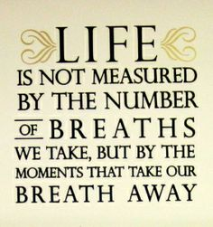
Researchers also discovered that the balancing out of pluses and minuses did not reinforce but, in fact, counteracted the effectiveness of the conditioning. This indicates that positive points do not cancel negative; unlike a balance sheet, these are not subtractive. So rewards must be issued corresponding to the successes, and punishments will also be issued in relation to the failures. Doing so strengthens the conditioning. Applying a balancing effect will have a counterproductive effect by always limiting the extent to which a reward or punishment can be expected.

Merit and Demerit Points
Having the submissive record the events of their day in a journal, and then weekly transcribe those activities which have previously been discussed as preferred or discourage behaviours allows the submissive to focus on their day. The activities are awarded points (positive – merit, negative – demerits) but categorized into the groups of the behaviour types. This allows the application of a sliding gauge of success “Ratio” to be measured for each grouping. The intensity of the reward or punishment occurs relative to the balance of the target behaviour.
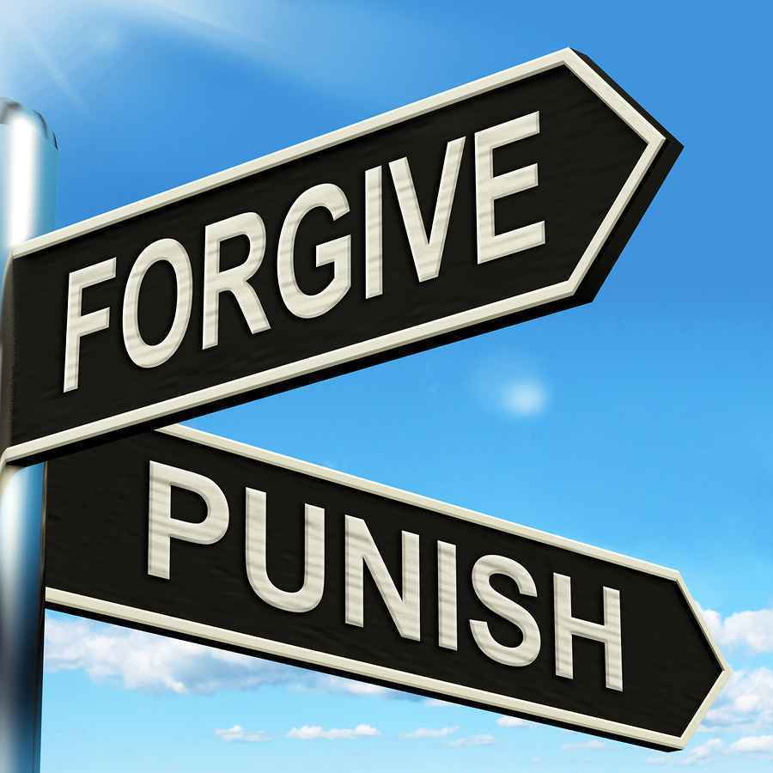
An alternative approach is merely a summation. Rather than the intensity, the duration or number of rewards or punishments is given out dependent on the number of times that the target behaviour occurs.
High priority activities or behaviours need to have a special value assigned them to increase the significance of the reward or punishment. This is particularly important as new activities or behaviours are being added to the set of expectation for a submissive. This is difficult to measure for every behaviour; therefore, the focus needs to be given to the ones deemed most critical to the desires, needs or skills sought as stated in the motivations section of this article. This will mean that adaptation to the schedule for review must accommodate reserve this schedule for special cases.

Random Reinforcement
The ability to make the reinforcements feel random increases the impact these have. A submissive that falls into a pattern becomes aware of the pattern and can influence the outcomes simply by manipulating the information provided. Critical in ensuring effectiveness is having the frequency remains frequent enough that the risk of punishment or potential for reward is stronger than the submissive’s preference for a different behaviour. The dominant and the submissive engage in a series of activities with repercussions and windfalls that are designed to keep it enticing without becoming an expectation. Consider, traffic enforcement which is designed to make people drive safe by the concept that, “Driving this way I will eventually be caught, even if not this time; is it worth it?

Differential Reinforcement
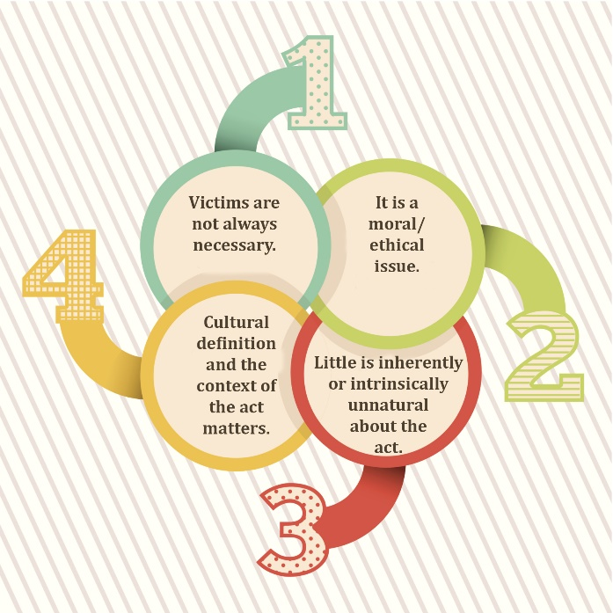
Researchers prefer approaching reinforcement with this approach as studies have shown that positive reinforcement is a more powerful, yielding consistent result over other types was parlayed into more resilience and less prone to the effects of erosion. The other major reason for this is from a humanities perspective “Positive Reinforcing” avoids the onset of resentment or depression or other deleterious effects which accompany a strict punishment approach. Finding ways to reward the submissive to behave better seems to have more efficacies with habits that formed over years. Punishment appears far more effective in avoiding new or countering the adoption of undesirable habits. Regardless of the target behaviour, positive or negative corrective responses must be aligned to them and focus on the most efficient way of attaining long-term results.

Eradicate
The more complex the set of personality traits, behaviours and activities which need adjustment or correction it is important to prioritize them. There may well be ones which can be tolerated even if only at first. There will be one or two, however, that manifest themselves which are abhorrent to the dominant, or will interfere with the domination of the subject. The focus needs to be targeting the ERADICATION of frequent, severe, and repetitive negative behaviours. The unmitigated eradication of high-priority problem behaviours is one area where punishment needs to be combined with rewards to the maximize effect.
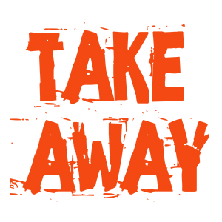
Simple yet meaningful rewards need to be designed for when undesirable behaviour is corrected by the submissive themselves. The rewards should only be coupled with the habit corrected.

During the workshop, a submissive had a particularly annoying habit of calling people by their first name all of the time. The submissive demonstrated a lack of respect by never using honorifics. Punishing the submissive was not working and after 3 days the dominant and Dominar decided to reward the submissive for each time this does not occur. They also made of point of drawing to the attention of the submissive and any audience that the show of respect was appreciated. By the end of the workshop, the submissive still had the fault but was exhibiting it in less than 1.4 of the interactions. The punishments for failure picked up but also changed in form during the workshop. After day 3 instead of verbally humiliating and berating the submissive had all verbal communications blocked by wearing a ball gag for two hours. This continued after the workshop, and 4 months late the couple were observed, and the ball gag which had perpetually hung around the submissive’s neck was not being worn. When questioned, the Dominant stated that while rare slips occur, as a rule, the submissive always address all people both in private and public now with proper respect and decorum. Even though this took a while to see the benefit of this technique, the behaviour was drastically and quickly reduces once it took effect.
  - Clinical Assessment
Participants volunteered up to 4 hours for debriefing after the workshop was completed the students were encouraged to disagree approaches, suppositions, etc. after the fact but were strictly prohibited from interfering during the execution of the workshop. The resulting analysis, perspective, and approaches were designed and implemented by the Dominar. Graduate students were given the opportunity to debrief sessions of the participants without the Dominar present but had to record all such interviews.

Review
Submissive’s were given journals to record items in for their own private purposes. They were instructed to record progress as it was being made. They were to record the type, intensity of any disciplinary action and their understanding of what precipitated it. They were also asked to record the same for rewards, particularly the one they felt were really special or touched them in some way. At the end of each day, they were asked to write both in their journal and on a note for the observers any particularly difficult situation they faced that day. These journals were only shared with the observers on a voluntary basis and should a submissive wish to keep it private this was respected. It should be noted that all but 1 did share, and in fact, all but that person also used their private journals when they wanted to discuss their understanding with the dominant which was engaging them.
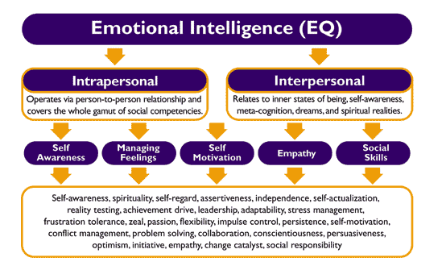
Progress was tracked closely by the observers and the dominants. Reviews were conducted with the dominants and observers at the end of each day for about ½ hour. As situations evolved the plans were adjusted as necessary. However, the students could not advise, only observe. The dominants had to determine if any adjustments were necessary and then make them accordingly. The intent was to NOT lose track and ensure in every situation the other dominants were aligned and no one would fail to follow through.

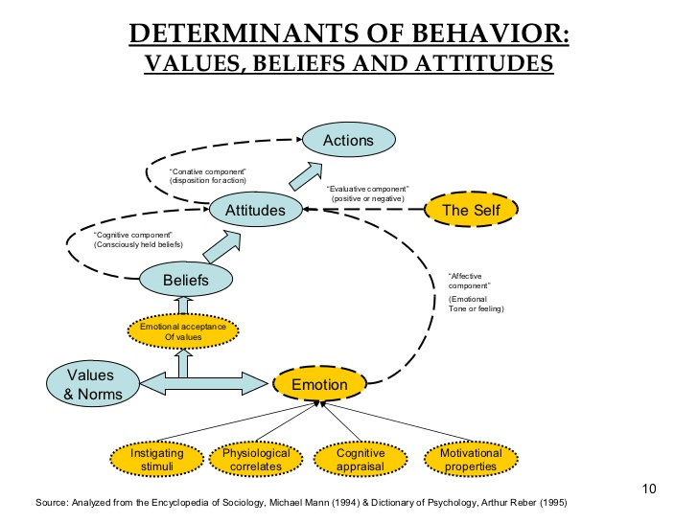
Determinants
Subsequent discussions with the graduate student showed that many of the theories appeared initially as “dysfunctional yet effective” but after deeper examination had a rational basis for the effects observed. This assessment is now provided for other DOMINANTS and submissives to assist them on deciding if to follow the suggested path outlined for them. Dominar Aramock is considered an “expert” in these practices based on a combination of academic education and over 40 years of refining the approach in real-life situations. While adopting the approach does not guarantee results it does increase the likelihood of success based on the assessment given by the graduate students.

Cultural Differences
Clearly with all of the subjects and the interpretations of the academics and students it became clear that perceptions were largely being driven by cultural backgrounds, training and affinity. The diversity of frequently predetermined the reaction between roles and individuals. One of the key factors was the level of power-distance exhibited as a part of the cultural norms of the respective individuals. A simple associative test of all of the individuals involve was conducted, solely based on the emotions by colour. The findings were 100% consistent other sociological studies conducted.
Academic Conclusion
The academics and graduate students concluded the brains of the submissives were constantly collecting information from others around them. But given the close proximity and narrow focus of the interactions this hastened the effects. The submissive’s each focused on one dominant what was expected in those interactions. This effectively removed the “societal noise pollution” from their existence. It was more effective the submissive with consistent and intense sessions than something that would have been scattered. Similar research of this type in a prison setting where academic investigators tried a level of training for 2 hours 2 days per week over a nine-month period. The effect and retention were ¼ of what was observed in the training done in the intense workshop and with follow-up sessions. It was clear the effectiveness of the actions which let the subject know what is expected is directly coupled to the intensity and intimacy of the relationships. The isolation of prison actually worked counter to the effectiveness of the conditioning training.

Potential Causes of Failure
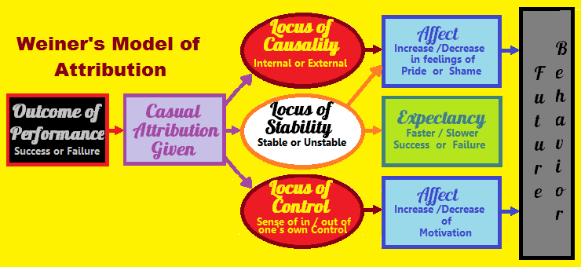
Not everything worked all of the time. In fact, about 30% of the habits wanting to be changed or added did not take place or could not be measured at the end of the workshop. Significant time was spent after the workshop to determine why the failure rate was so large. The observers and academic advisors we of great help in doing this assessment based on the observations, notes take and interviews at the end of the workshop. The most prominent reasons discovered were:

Ineffective Reinforcement
The reinforcing failed because:
- The reinforcements were not relevant to the submissive
  - Punishments did not seem to be related to the action
  - Rewards were too intangible to be recognized by the submissive
  - The submissive became “bored” with the reward
  - There was a lackluster approach to the administration of some punishments
  - There was NO emotional bond to the Dominant
- The ratio of task was too high and “Satiation” has occurred
  - It appeared that some of the dominants were pushing all of the pet fetishes and had little regard for the submissive or their objectives
  - To many activities were taking place in too short a time, as result, there was no time to absorb the lessons learned
- It became surreal towards the end, as a couple of dominants and submissives realized there would be no continuation after the workshop in their relationship

Inconsistent Delivery
- The dominant forgot to explain why.
- Was late or disinterested in reinforcing appropriate and punishing inappropriate behaviour.
- The submissive is unable to engage in the alternative/desired behaviour.

  - Helpful Links:
One of the most comprehensive submissive resource and support sites I’ve ever found. Great for un-partnered submissives who wish to better themselves without a dominant.

Classical ttp://en.wikipedia.org/wiki/Classical_conditioning
Dominance and Submission http://en.wikipedia.org/wiki/Domination_%26_submission_(BDSM)
Operant Conditioning http://en.wikipedia.org/wiki/Operant_conditioning
Question and Answer Forum http://www.AlllExperts.com/el/BDSM/
Submissives (BDSM http://en.wikipedia.org/wiki/Submissive_(BDSM)
Mentoring and Submission http://SubmissiveGuide.com

